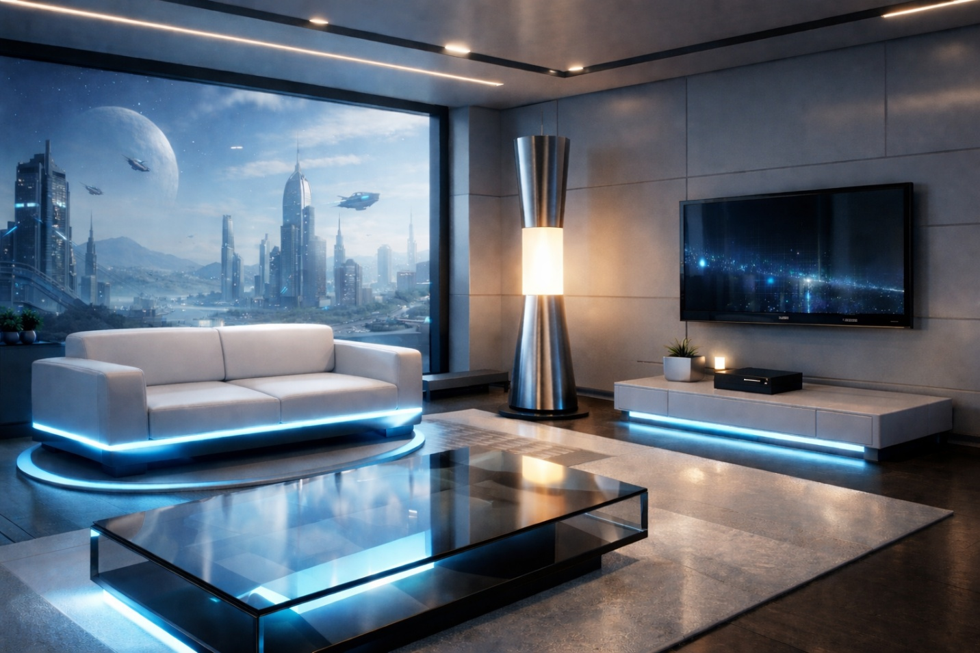

For my 2D reference, I selected the futuristic living room image shown above, which features a sofa, a coffee table, a floor lamp, a TV console, and the surrounding architectural space. This image works well as a 2D source because it clearly shows multiple objects with strong geometric forms and simple silhouettes that will translate well into a 3D model. This scene contains more than four distinct objects and provides enough visual interest to recreate in 3D without becoming overly complex.
The main objects I would replicate in 3D are the couch, the coffee table, the floor lamp, the TV, and the TV stand, with the floor acting as the base of the scene. These items are good choices because they vary in scale and shape complexity while still being achievable using basic 3D shapes. Together, these objects create a balanced scene that feels complete and visually engaging while remaining manageable for creating my first full 3D scene.
Each object can be broken down into simple 3D shapes. The floor would be created using a plane to ground the scene and establish the scale. The couch can be modeled primarily with boxes for the seat and back cushions, with prisms or slightly modified boxes for the armrests. The coffee table uses a box for the tabletop and thinner boxes or cylinders for its supports. The TV stand is also composed of stacked boxes, while the TV screen itself can be a thin box with a slightly recessed face to suggest depth.
The floor lamp is the object that requires multiple shapes, making it the most complex in the scene. Its base and stem can be modeled using a tapered cylinder, while the center section can be a standard cylinder. These choices make sense because they mirror the actual geometry of the objects while keeping the modeling process simple. Overall, this scene is fun to explore because it allows experimentation with scale and composition while remaining achievable by relying mainly on foundational 3D shapes.

